Platform Overview
The proposed platform seeks to build on and complement the strengths of IGAD and its affiliates. The platform will act as a user focussed knowledge management system that aligns information from across the IGAD network with use cases that support innovation development. Below is an overview schematic of have the hub will generate information and lead to innovation outcomes amongst its users.
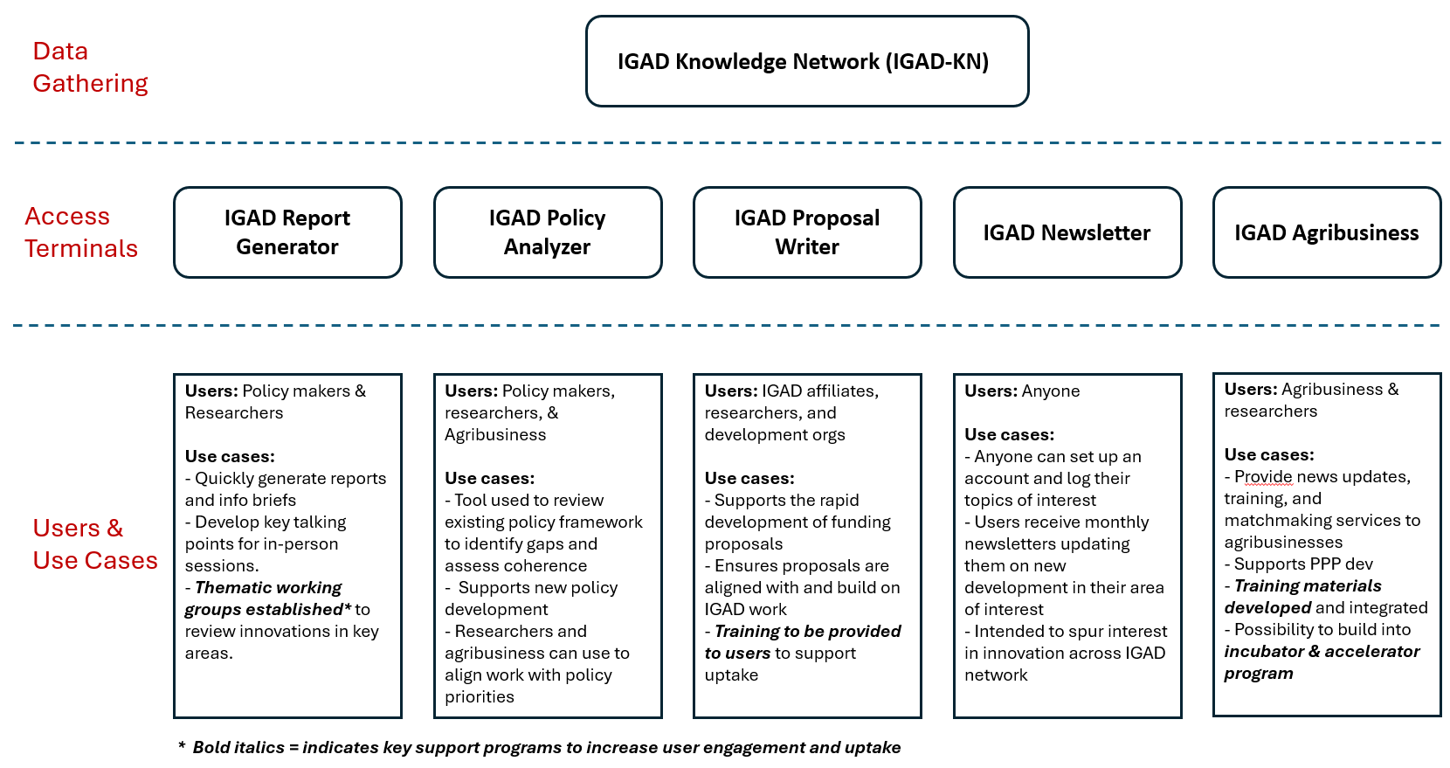
Figure 1: Overview of innovation hub structure and use cases.
The innovation hub can broadly be divided into three core components. The first component is the IGAD Knowledge Network (IGAD-KN), which is a data gathering tool that will continuously scan the webpages of IGAD and its affiliates to gather information that is relevant for the platform’s users. The IGAD-KN will be developed through the design and implementation of an AI assistant that will monitor the websites and databases manged by IGAD and its partners. The AI tool will keep abreast with recent publications and develop a back-end repository to tag and store key information. This store will them be accessed by a number of user facing access terminals each with a defined use case.
The information collected and sorted by the IGAD-KN will then be accessible to users through five access terminals. Each access terminal fulfils a specific function based on the identified demand from IGAD members and affiliates. The five access terminals are as follows:
- IGAD Report Generator – This terminal will generate summary reports drawing on information from the IGAD-KN. The content of the reports will be generated using AI based on prompts provided by the user, with templates and guidelines provided to support the user.
- IGAD Policy Analyzer – This terminal will allow users to quickly review the current policy frameworks of IGAD and the member states. The tool will use an AI tool to draw information from all available policies related to areas the user is looking into.
- IGAD Proposal Writer – This terminal will support IGAD and its members to develop funding proposals that build on existing work located in the IGAD-KN. This process will improve the efficiency and consistency in the proposals developed.
- IGAD Newsletter – This terminal will collect information on the interests of users and develop bespoke newsletters for them based on their areas of interest. These newsletters will capture updates from the IGAD-KN and will also tap into other external news sources to bring in information on other innovations and funding opportunities.
- IGAD Agribusiness – This terminal will track agribusiness developments and funding opportunities. Providing high level insights to sectoral actors and targeted recommendations to businesses. The tool will also integrate training modules to support agribusinesses overcome common hurdles.

Box 1: Key thematic areas for innovation development
The following thematic areas have been identified as key focus areas for innovations that support pastoralist communities across IGAD member states.
Climate Information & Advisory Services
•Climate Information Services
•Disaster and Conflict Early Warning Systems
•Climate Advisory Services
•E-Extension & Decision Support Tools
Market Access & Value Chain Development
•Digital Livestock & Agro-Product Marketplaces
•Traceability & Supply Chain Transparency
•Processing, Storage & Cold Chain Monitoring
•Cross-Border Trade & Digital Mobility Platforms
E-Governance Initiatives
•E-Registry for Herders
Natural Resource Management
•Water Point Management
•Digital Grazing Maps and Satellite-Based Forage Projections
Financial Access & Risk Management
•Digital Credit Services
•Index-Based & Parametric Insurance
•Digital Remittances & Payment Solutions
Health Monitoring
•Livestock Health Monitoring & Predictive Disease Surveillance

Acknowledging that such tools are rarely adopted automatically, a series in-person platforms and training materials will be developed to support potential users and promote identified use cases. These events and materials will be rolled out as the different access terminals are bought online. Some of the key activities to support user uptake include:
- Establishment of thematic working groups – Thematic working groups will be established covering a number of key thematic areas (see Box 1 on thematic areas) important for innovation uptake and scaling across the IGAD region. The IGAD Report Generator will be used to help guide the discussion during such sessions, bringing in key information covering recent research and developments on innovations form across the IGAD network.
- Training materials for proposal development – Training materials will be developed to support users of the IGAD Proposal Writer to best utilise the tool to apply for funding proposals.
- Agribusiness training materials – Training modules will be developed and integrated into IGAD Agribusiness to support the tool in guiding existing and prospective agribusinesses through some of the common challenges faced.
- Incubator & Accelerator program – Once the IGAD Agribusiness platform has established a sufficiently large network, incubator and accelerator programs can be run through it, building on areas of key interest.

